2013 Colonial Williamsburg Rod Run Application
http://www.tsra-va.com
**********April 26 & 27, 2013********** FB
THE FIRST 100 PRE-REGISTERED PARTICIPANTS WILL RECEIVE A FREE T-SHIRT
AND WILL QUALIFY FOR SPECIAL PRIZES!!!
See directions to car show on next page
Name: ____________________________________ Spouse’s Name: _________________________________
Address: _________________________________________________________ Phone: __________________
City: ___________________________________State:__________________________ Zip Code: __________
Email: ____________________________________________________________________________________
Type of Car (Pre ’73 Only) Year: ________ Make: ___________________________ Model: _____________
Club Affiliation(s): _______________________________________ Will this be your first year? ___yes ___no

1ST 100 PRE-REGISTERED PARTICIPANTS ONLY QUALIFY FOR FREE T-SHIRT;
ALL PRE-REGISTERED WILL QUALIFY FOR SPECIAL PRIZES!!!
(To qualify for free T-shirt your registration MUST BE RECEIVED by TSRA on or before April 1, 2013)

*************T-Shirt Size for One Day or Two Day Pre-registered __________________*************
++We must have time to order your shirt size so be sure to get your registration to us by April 1, 2013++
Registration Fees: Received by TSRA by April 1, 2013 After April 1, 2013
Two-day Car Show Registration (Includes Friday Dinner for one)  Saturday only car show | $25.00 _________  $18.00 _________ | $30.00 ________  $20.00 ________
Additional Friday Dinner (per person)  Children’s dinner (under 12 yrs.) | $10.00 x ____ = _________  $ 5.00 x ____ = _________ | $10.00 x ___ = _____  $ 5.00 x ___ = _____
Vendors – Saturday only | $25.00 _________ | $30.00 ________
Vendors – Friday & Saturday | $35.00 _________ | $40.00 ________
 | TOTAL ENCLOSED = _________ | TOTAL ENCLOSED = _______
****************************************************************************
LIABILITY
In consideration of the acceptance for the right to participate, all entrants and spectators, by execution of this form, expressly release and discharge Tidewater Street Rod Association, Inc. and T/A Colonial Williamsburg Rod Run and Colonial Williamsburg Hotels and all their officers, directors, employees, agents, representatives, servants, and anyone else connected with the management or representation of Tidewater Street Rod Association, Inc. and T/A Colonial Williamsburg Rod Run and Colonial Williamsburg Hotels of and from any causes whatsoever that may be suffered by any amount to his/her person and/or property.
SIGNATURE: ____________________________________________ DATE: ____________
^^^^^^^^^^^^ cut here and send portion above to: ^^^^^^^^^^^^

Colonial Williamsburg Rod Run
C/o Tidewater Street Rod Association
P.O. Box 9181
Hampton, Virginia 23670
Visit our website for additional information: http://www.tsra-va.com
Larry Anderson 757/547-3769 or Marvin Blalock 757/850-0064
Please send a self-addressed stamped envelope/post card for confirmation.
REGISTRATION CHECKS: Please make payable to: COLONIAL WILLIAMSBURG ROD RUN
Entrance into the car show area will be restricted to registered show cars only
Please Note: The TSRA reserves the right to refuse any vendor, flea market, or street rod registration
Grand Prize winners must be registered as a car participant with their vehicle at the show.

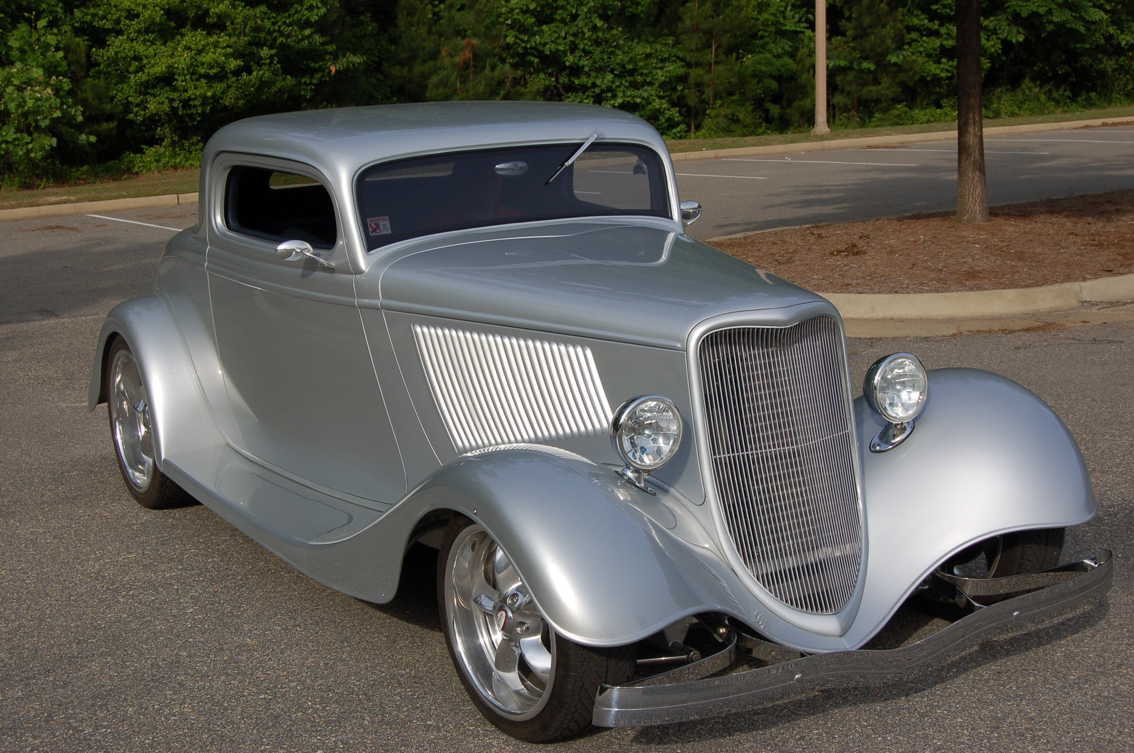 | 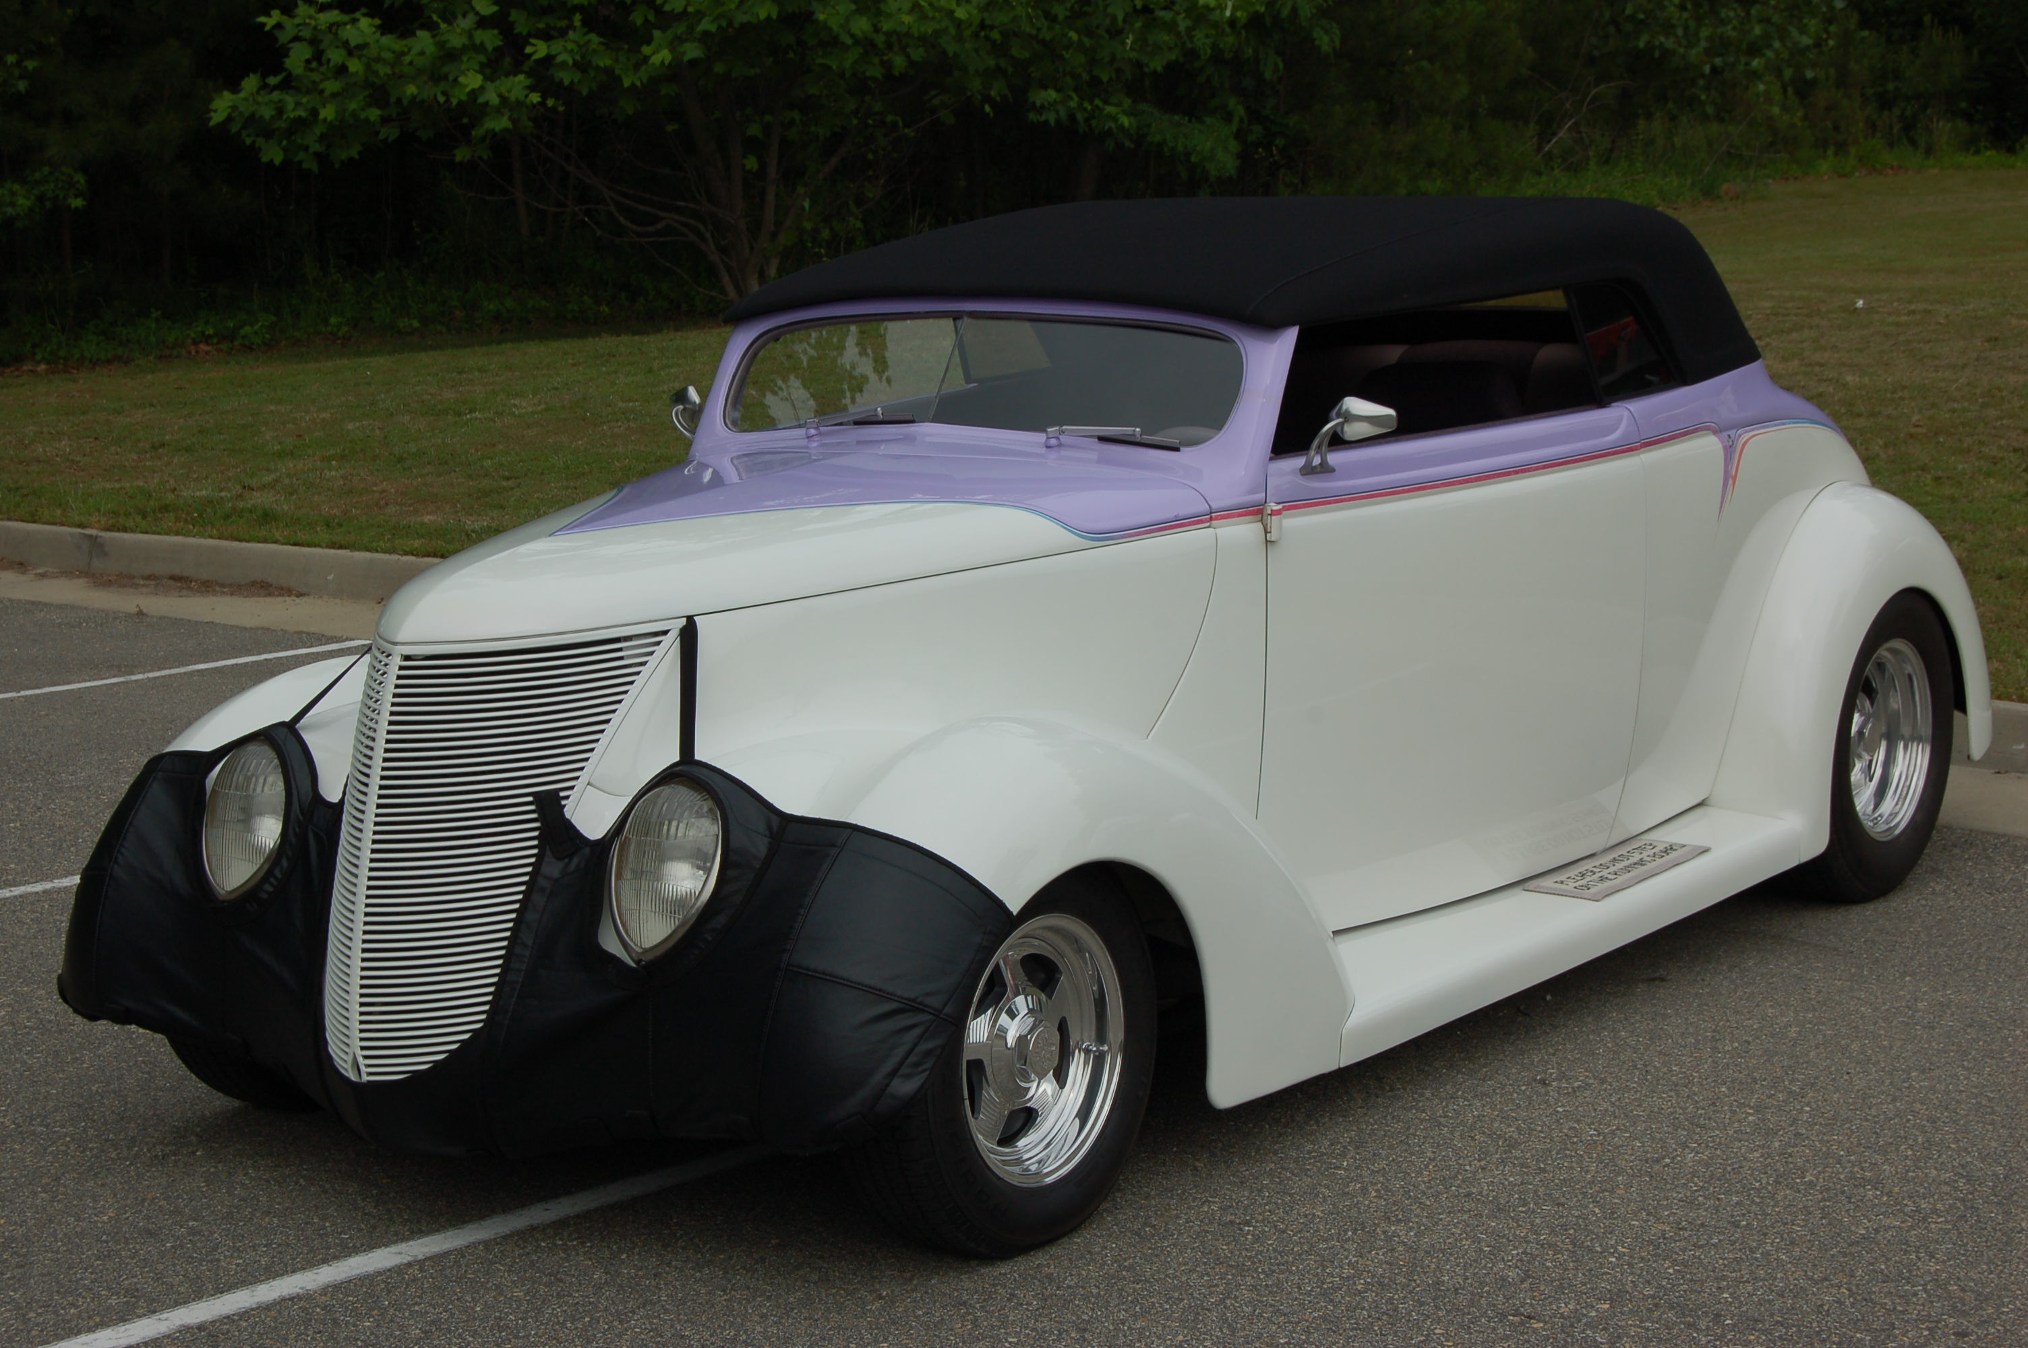
The Tidewater Street Rod Association proudly presents the…
41st Annual Colonial Williamsburg Rod Run….
********** April 26 & 27, 2013 **********
For only $25 Pre-registered 2-day event You Get: A free event T-shirt (1st 100 registrations received only), Friday afternoon car show, a BBQ & Chicken dinner Friday evening (for driver only), an organized cruise around Williamsburg Friday evening, Saturday car show, poker run, games, and a chance of winning one of several Grand Prizes! At this price, how can you not come and join us for our 41st Anniversary? Events are subject to change without notification.

Directions to Car Show: From I-64 take exit 238 onto Rt. 143 East toward Williamsburg/Jamestown/Yorktown. Follow Rt. 143 approximately ½ mile and turn right at the traffic light onto Rt. 132 South. Follow Rt. 132 about 1.2 miles and turn left at the traffic light onto Rt. 60 (Bypass Road). Turn right at the first street and this will put you on the Colonial Williamsburg property. Turn left at the first street and the car show will be just ahead in the parking lot on the left (address: 101A Visitor Center Drive)

____________________________________________________________________________________________________________________________________________________________________________________

Colonial Williamsburg Rod Run
C/o Tidewater Street Rod Association
P.O. Box 9181
Hampton, VA 23670

